Portfolio Website Project Documentation
1. Project Title
Personal Portfolio Website

2. Problem Statement
In the current digital world, recruiters and companies prefer to review candidates through online profiles and portfolios. Many students only rely on resumes, which do not effectively demonstrate their technical skills or projects.
Therefore, there is a need for a personal portfolio website where developers can showcase their skills, projects, and resume while also providing an easy way for recruiters to contact them.

3. Project Objective
The objective of this project is to develop a personal portfolio website that presents my technical skills, projects, and professional information in an organized manner.
The main objectives are:
- To create a professional online presence.
- To showcase technical projects and skills.
- To provide recruiters with easy access to my resume.
- To allow recruiters to contact me through a contact form.
- To demonstrate my knowledge of frontend and backend development.

4. Technologies Used
Frontend
- HTML
- CSS
- JavaScript
- Font Awesome (for icons)
Backend
- Python Flask
Database
- MySQL
Email Service
- SMTP (Simple Mail Transfer Protocol) for sending email notifications

5. System Architecture
The portfolio website follows a client-server architecture.
- The user visits the portfolio website.
- The frontend interface displays the website sections such as Home, Skills, Projects, and Contact.
- When a visitor fills out the contact form, the data is sent to the Flask backend.
- The backend processes the data and stores it in the MySQL database.
- An email notification is sent to the developer via SMTP.
This architecture ensures smooth communication between the frontend interface and backend server.

6. Features of the Portfolio Website
The portfolio website includes several features to enhance usability and functionality:
- Responsive website design
- Animated hero section
- Skills display section
- Projects showcase section
- Resume download option
- Contact form for recruiter communication
- Email notification when a message is received
- Social media links integration

7. Website Modules
1. Home Section
The home section introduces the developer with a dynamic typing animation showing the name and professional role.
2. About Section
This section provides a brief introduction about the developer, including education and career goals.
3. Skills Section
The skills section highlights the technologies and programming languages known by the developer.
Example skills:
- Java
- HTML
- CSS
- JavaScript
- Python
- MySQL
4. Projects Section
This section displays the projects developed by the developer along with a short description and GitHub links.
5. Resume Section
This section allows visitors to download the developer's resume in PDF format.
6. Contact Section
The contact section includes a form where visitors can submit their name, email, and message to communicate with the developer.

8. Database Design
The project uses a MySQL database to store contact form submissions.
Contact Table Structure
Field | Type | Description
id | INT | Unique ID for each message
name | VARCHAR | Name of the sender
email | VARCHAR | Email of the sender
message | TEXT | Message sent by the user

9. Implementation Details
Frontend Development
The frontend of the portfolio website was developed using HTML, CSS, and JavaScript. CSS was used to design the layout, colors, and responsiveness of the website.
Backend Development
The backend was developed using the Flask framework. Flask routes were created to process contact form submissions.
Database Integration
The Flask application connects to the MySQL database using a Python database connector to store user messages.
Email Notification
SMTP is used to send an automatic email notification whenever a visitor submits the contact form.

10. Project Screenshots
The following screenshots should be included in the documentation:
- Home Page
- Skills Section
- Projects Section
- Contact Form
- Resume Download Button

11. Advantages of the Project
- Provides a professional online presence
- Showcases technical skills and projects
- Helps recruiters easily contact the developer
- Demonstrates full-stack development knowledge

12. Future Enhancements
Some improvements that can be added in the future include:
- Adding an admin dashboard to manage messages
- Adding authentication for admin access
- Deploying the website on a cloud platform
- Adding more interactive UI elements
- Integrating analytics to track visitors

13. Conclusion
The Portfolio Website project successfully demonstrates the developer’s skills, projects, and professional information in a well-organized platform. The integration of frontend design, backend processing, database storage, and email notifications shows practical implementation of full-stack development concepts.

14. Project screenshots:
1. Home page
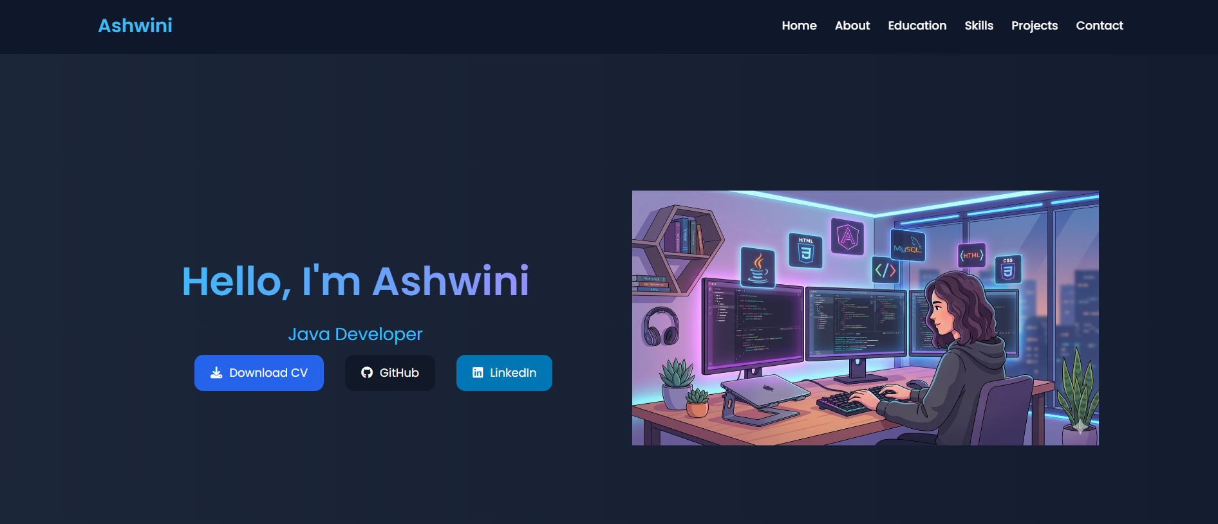

2. About Section
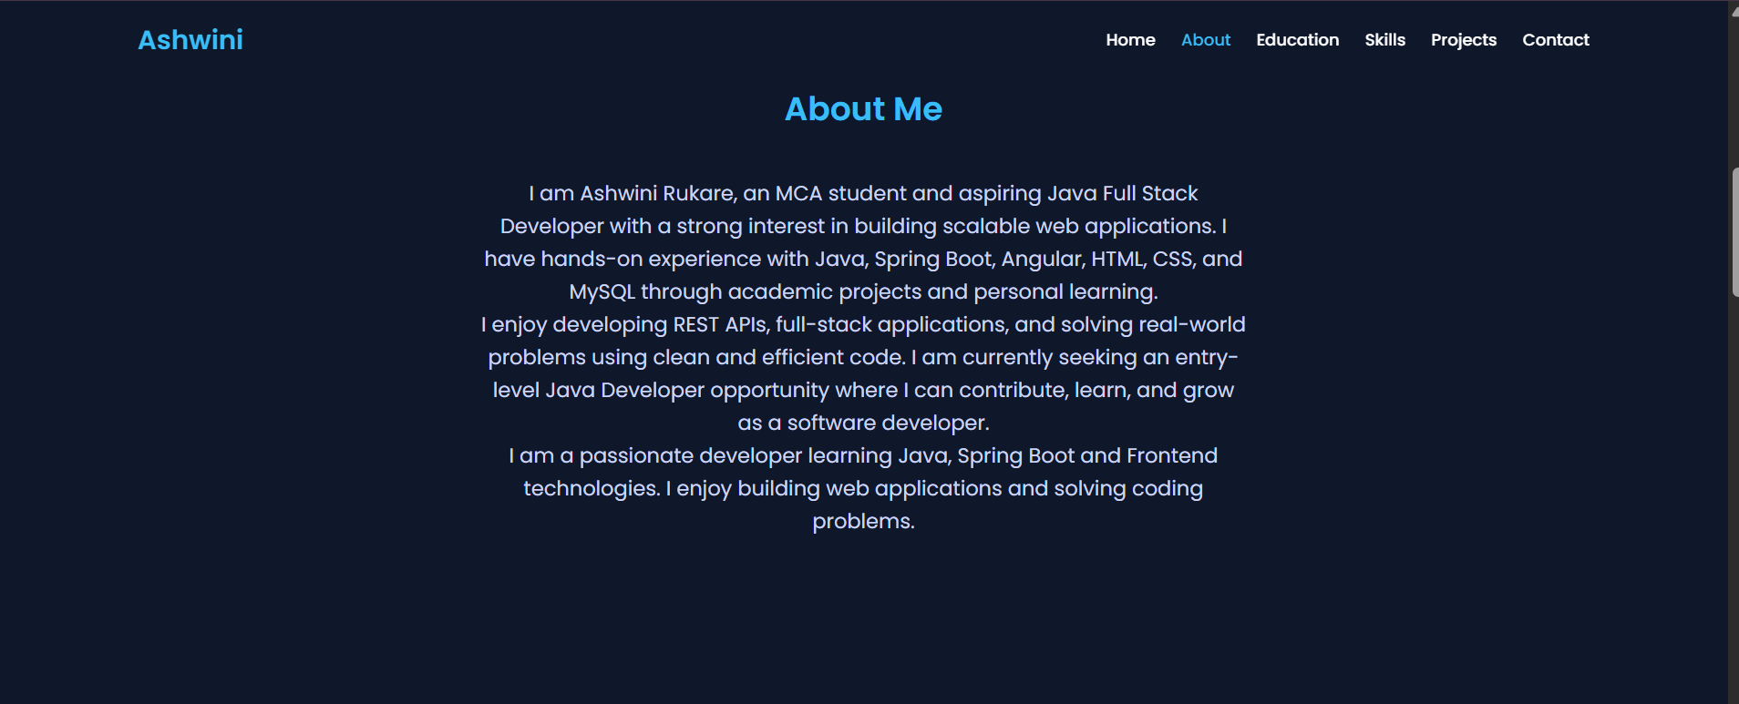

3.Education section
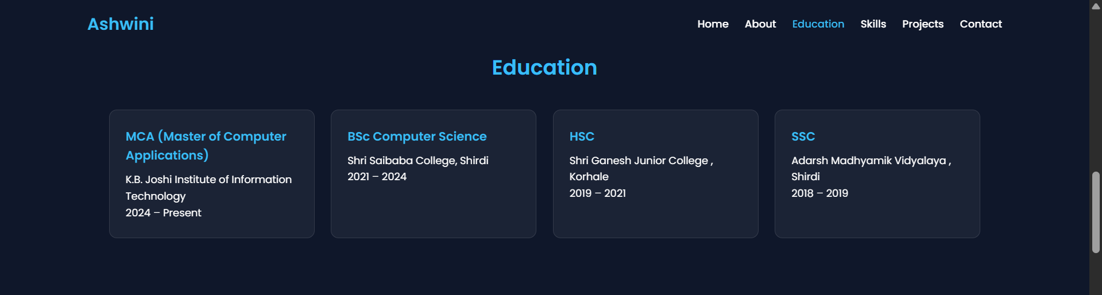

4. Skills Section
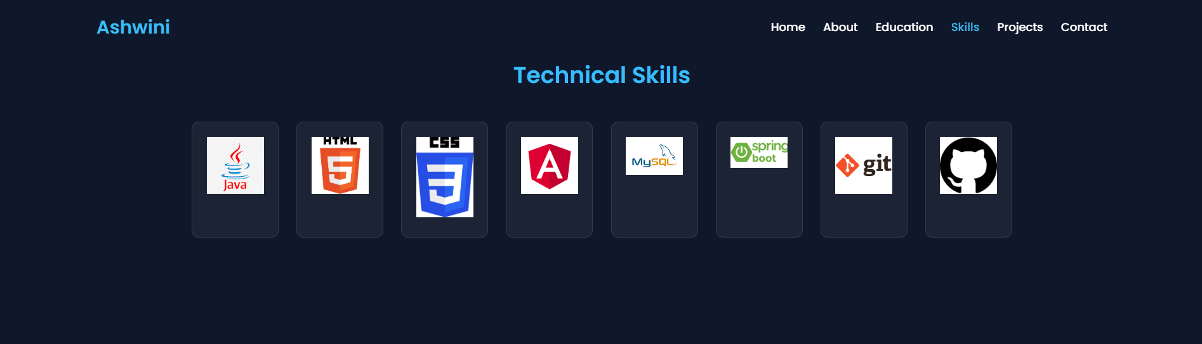
5.Projects Section
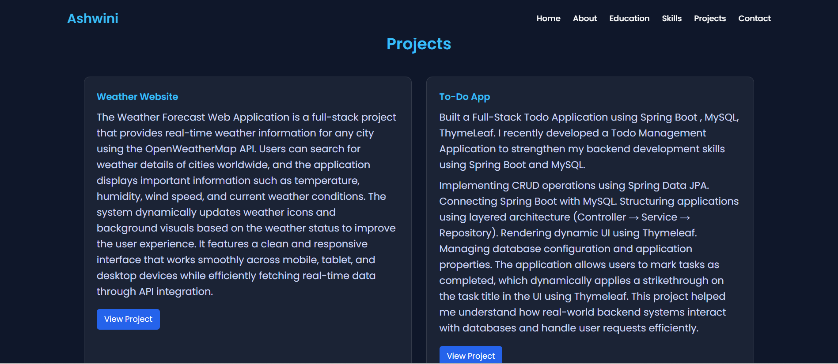
6.Contact Section
